 |  |  |  |  |  |  |  |  |  |  |  |  |  |  |  | Tree nuts
Resident’s last name |  |  | Resident’s first name | Resident’s ID | Milk (dairy) | Egg | Fish | Crustacean | Mollusc | Sesame | Lupin | Peanut | Soy | Wheat | Gluten | Almond | Brazil nut | Cashew | Hazelnut | Macadamia | Pecan | Pine nut | Pistachio | Walnut | Other allergies/ dietary requirements
 |  |  |  |  |  |  |  |  |  |  |  | 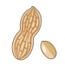 |  | 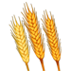 |  | 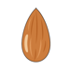 |  |  | 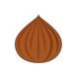 |  |  |  | 